LACR Search

**Simple Searching**

Can you use the app to search for your own name in the documents? If your name gives no results, try using the name Johnson.

*How easy was it to do this?*

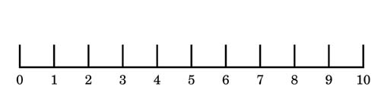

Impossible Extremely Easy

Additional Comments?

**Advanced Search**

Using the Advanced Search try adding additional search criteria to your search such as volume, page or year.

*How easy was it to do this?*



Impossible Extremely Easy

Additional Comments?

**Configuring your search**

Once you have made a search you can further configure the results.

The configurations are:

* Spelling Variants: - *Is how different the results can be. The number represents the amount of characters can be different in the results.*
* Criteria: - *What kind of results will show. Allows you to specify if the word comes at the start, middle or end of a word.*
* Sort: - *Allows you to sort the results by any of the ways specified in the dropdown menu*

Try configuring your results from the advanced search and see what the different results are.

*How easy was it to do this?*



Impossible Extremely Easy

Additional Comments?

**Browsing Documents**

Aside from searching through documents the app allows you to simply browse through the documents in the database. It also allows you to download the files and pictures.

Try Browsing through the documents:

*How easy was it to do this?*



Impossible Extremely Easy

Try Downloading some files:

*How easy was it to do this?*



Impossible Extremely Easy

Additional Comments?

Thank you for taking the time to use our app.

If you have any additional comments, you want to make use the space below: